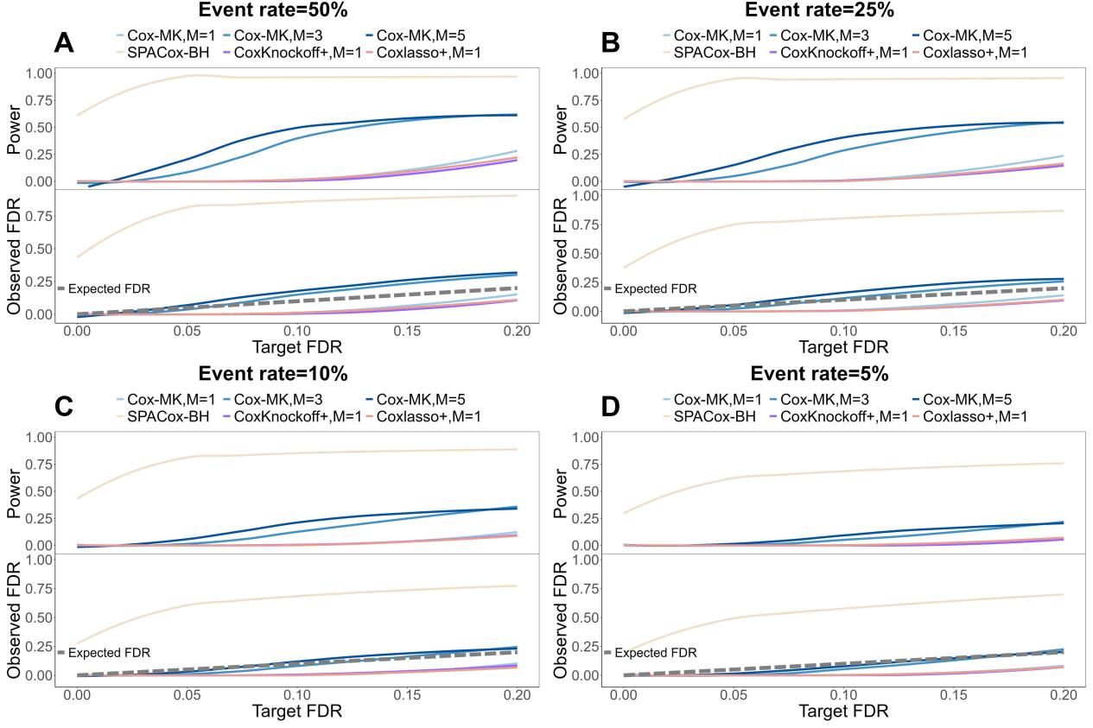
Figure S1. Power and FDR of Cox-MK, SPACox-BH, CoxKnockoff+, and Coxlasso+ using an LD cutoff of 0.8. Panels A-D summarize results across four event rates (50%, 25%, 10%, and 5%) based on 500 simulation replicates. Power is shown in the top row, and FDR in the bottom row, for each event rate. Cox-MK is evaluated using M = 1, 3, 5 knockoffs.

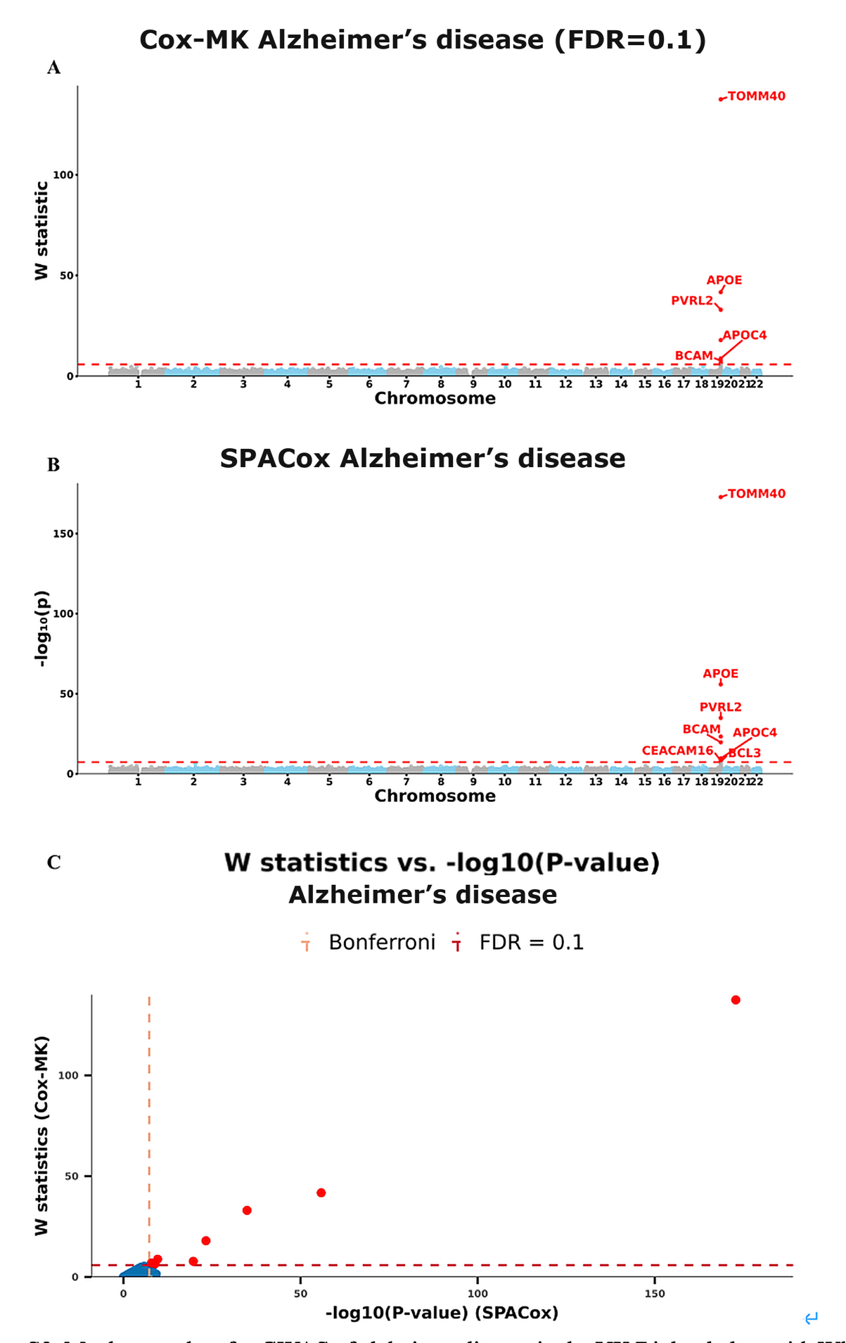
Figure S2. Manhattan plots for GWAS of Alzheimer’s disease in the UK Biobank data with White British ancestry. (A and B) GWAS results using (A) Cox-MK and (B) SPACox are shown for Alzheimer’s disease. (C) Scatter plot of W knockoff statistics (Cox-MK) vs. −log10(P-value) (SPACox) for Alzheimer’s disease.
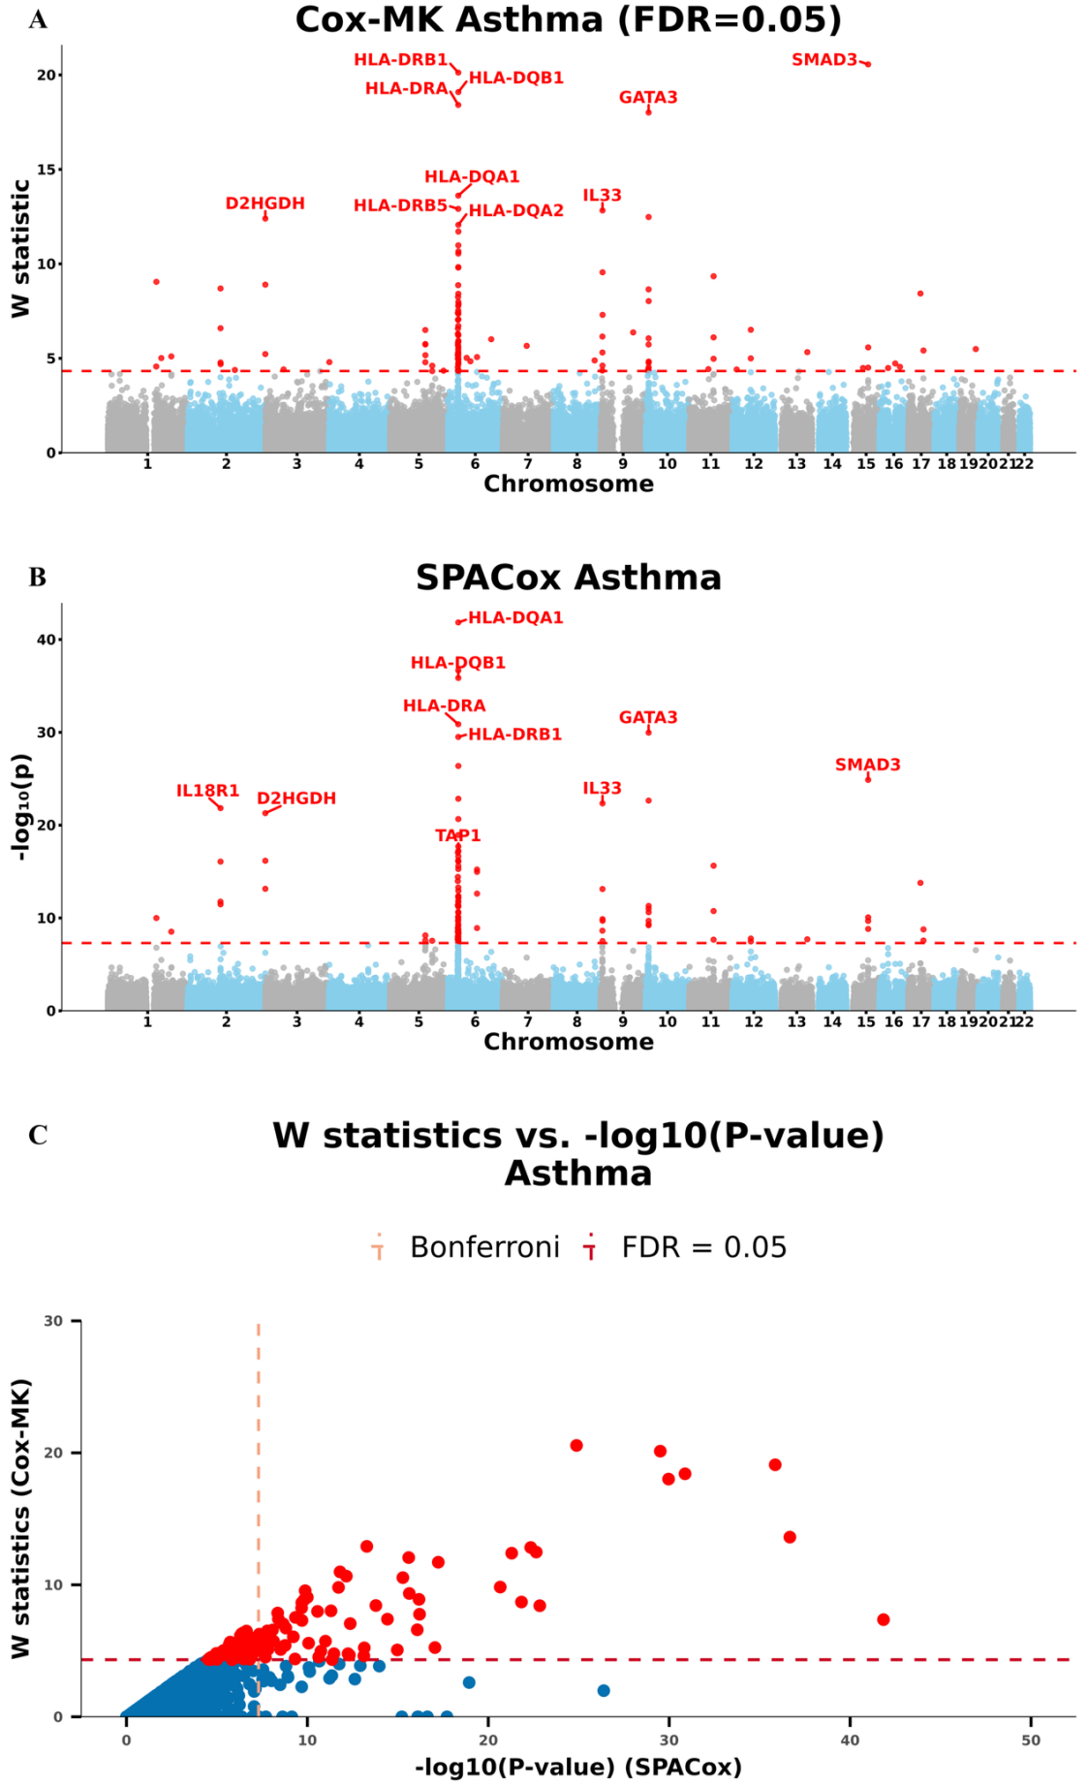
Figure S3. Manhattan plots for GWAS of asthma in the UK Biobank data with White British ancestry. (A and B) GWAS results using (A) Cox-MK and (B) SPACox are shown for asthma.
- Scatter plot of W knockoff statistics (Cox-MK) vs. −log10(P-value) (SPACox) for asthma.
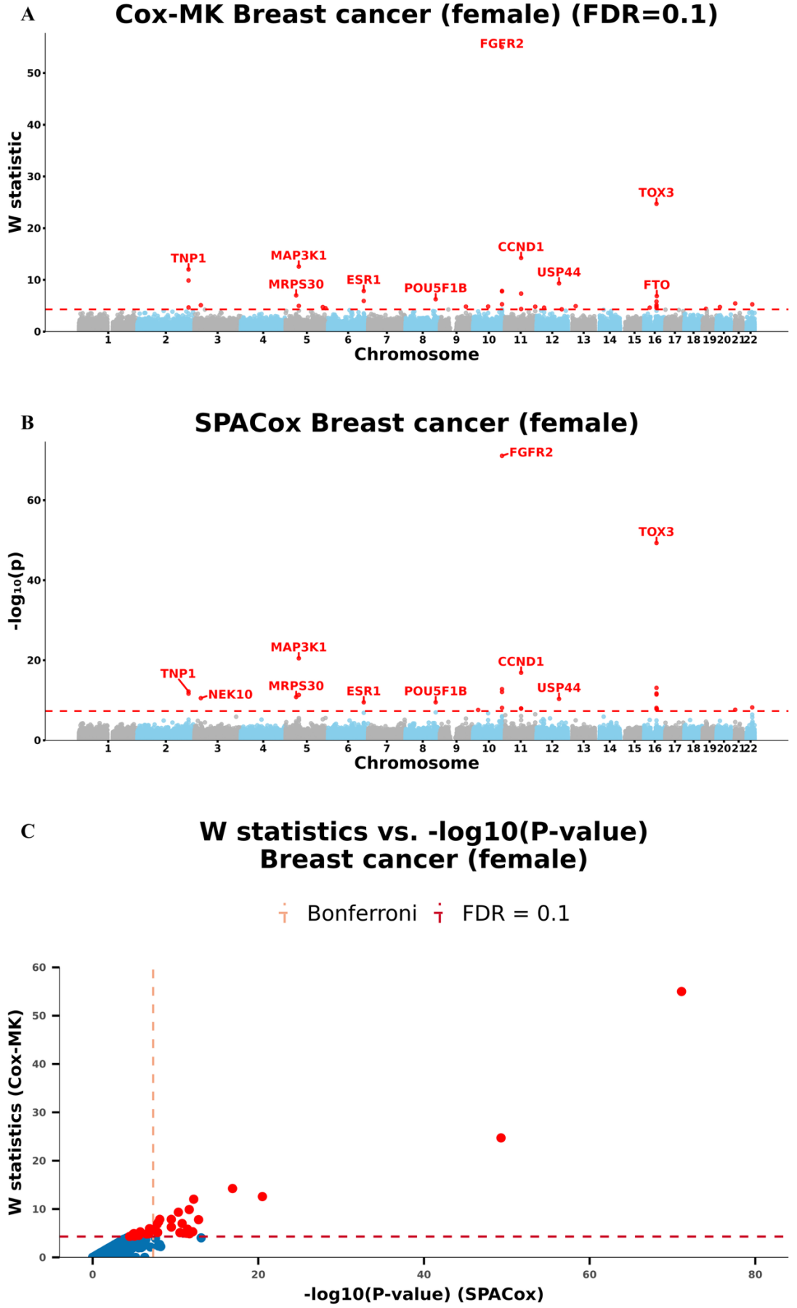
Figure S4. Manhattan plots for GWAS of breast cancer (female) in the UK Biobank data with White British ancestry. (A and B) GWAS results using (A) Cox-MK and (B) SPACox are shown for breast cancer (female). (C) Scatter plot of W knockoff statistics (Cox-MK) vs. −log10(P-value) (SPACox) for breast cancer (female).
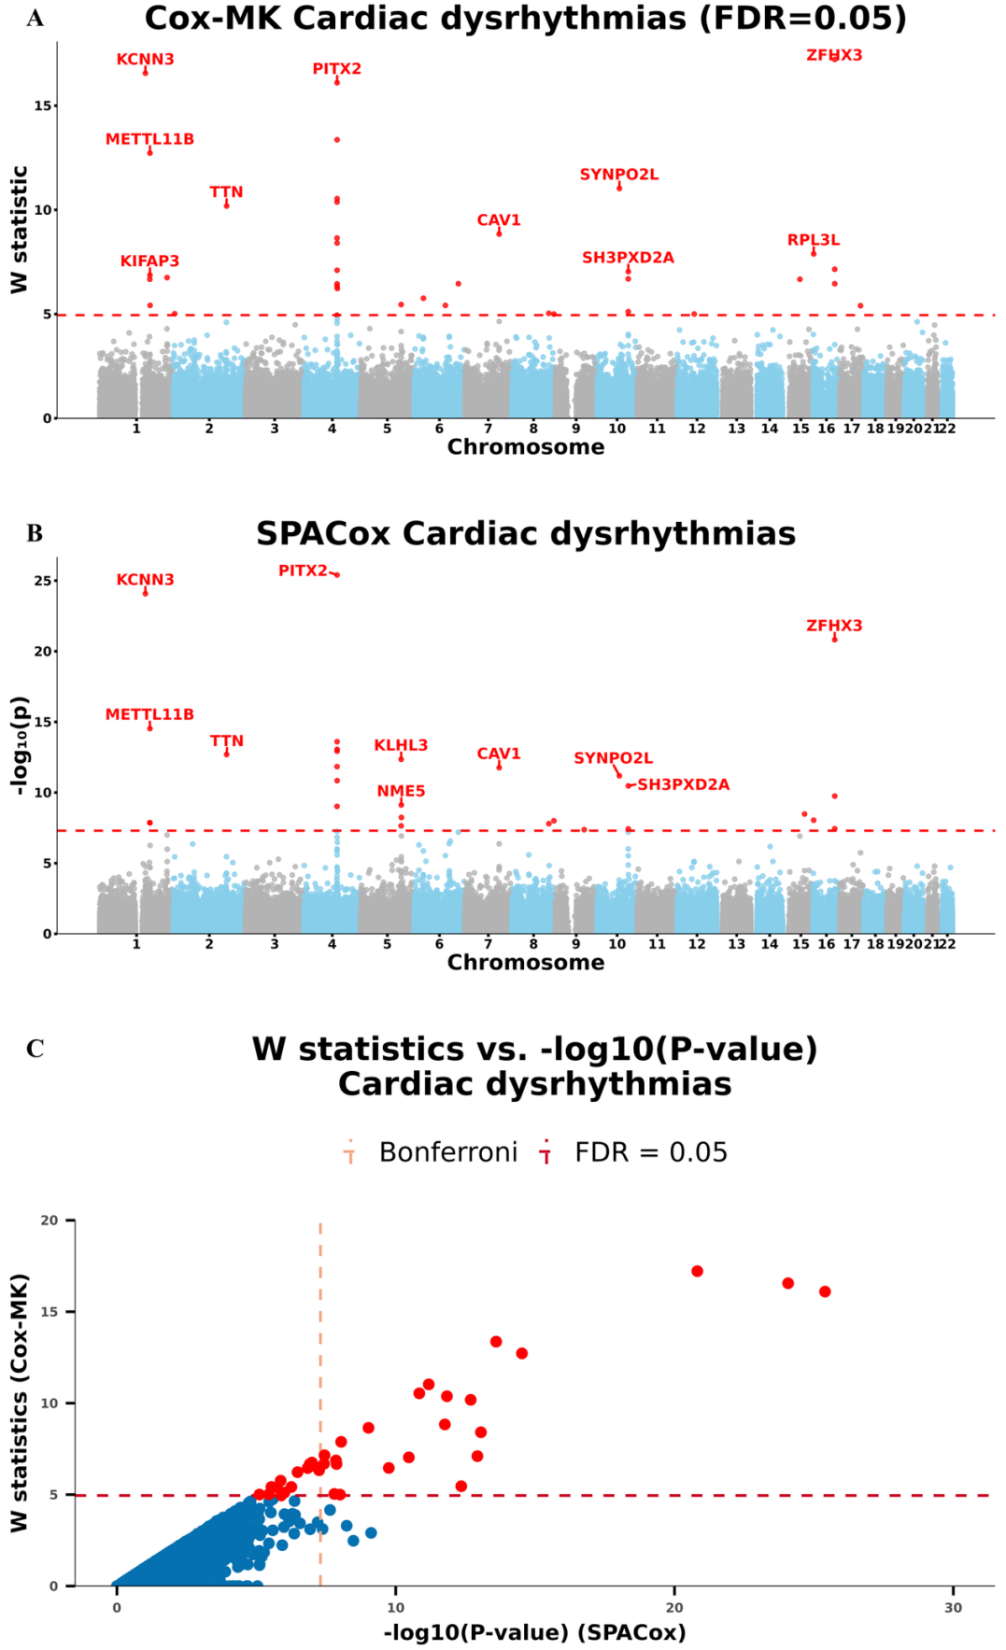
Figure S5. Manhattan plots for GWAS of cardiac dysrhythmias in the UK Biobank data with White British ancestry. (A and B) GWAS results using (A) Cox-MK and (B) SPACox are shown for cardiac dysrhythmias. (C) Scatter plot of W knockoff statistics (Cox-MK) vs. −log10(P-value) (SPACox) for cardiac dysrhythmias.
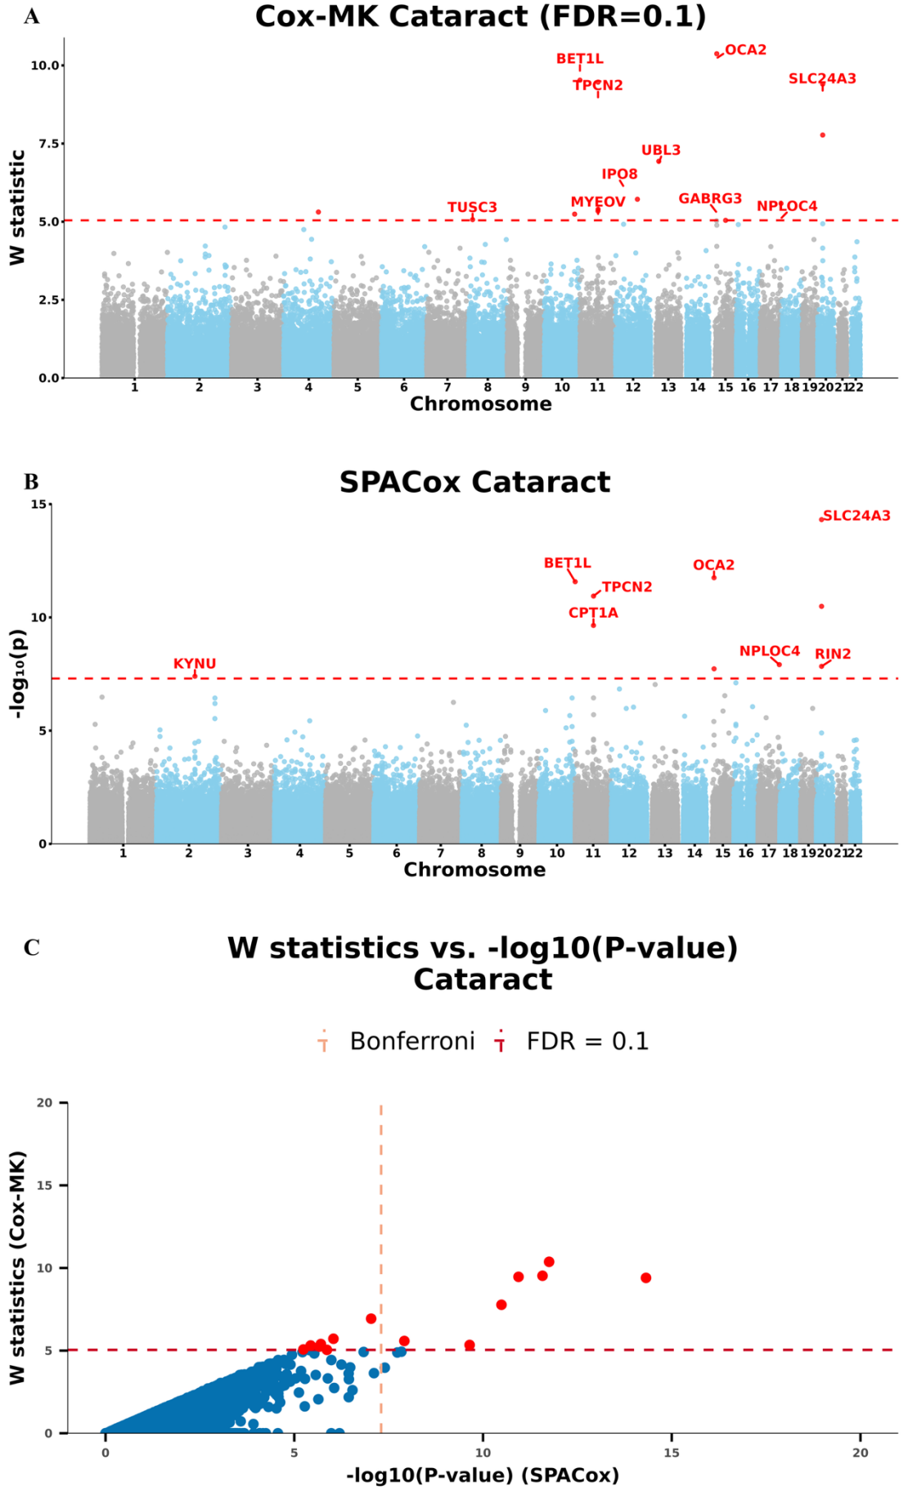
Figure S6. Manhattan plots for GWAS of cataract in the UK Biobank data with White British ancestry. (A and B) GWAS results using (A) Cox-MK and (B) SPACox are shown for cataract. (C) Scatter plot of W knockoff statistics (Cox-MK) vs. −log10(P-value) (SPACox) for cataract.
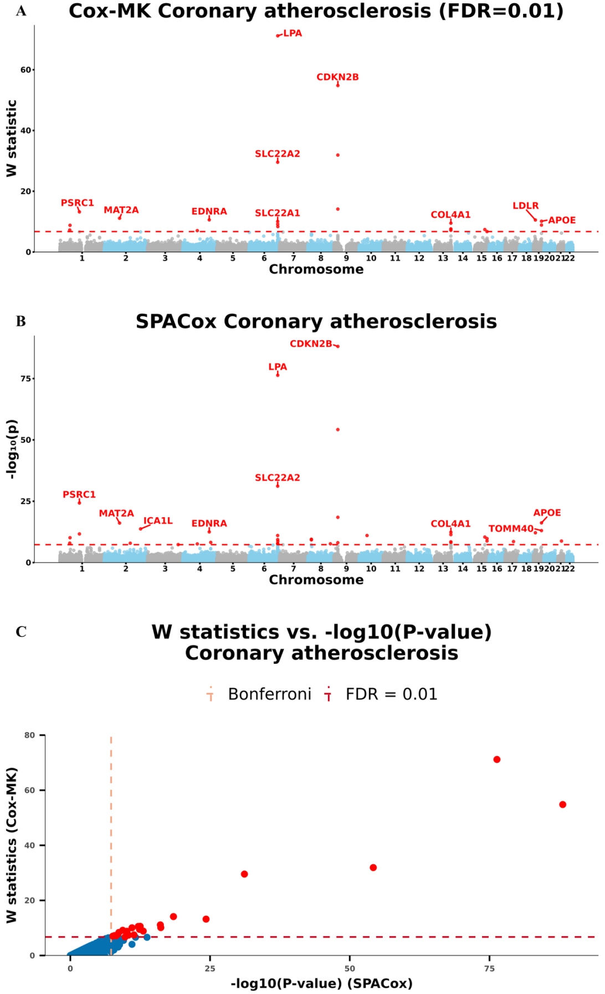
Figure S7. Manhattan plots for GWAS of coronary atherosclerosis in the UK Biobank data with White British ancestry. (A and B) GWAS results using (A) Cox-MK and (B) SPACox are shown for coronary atherosclerosis. (C) Scatter plot of W knockoff statistics (Cox-MK) vs. −log10(P-value) (SPACox) for coronary atherosclerosis.
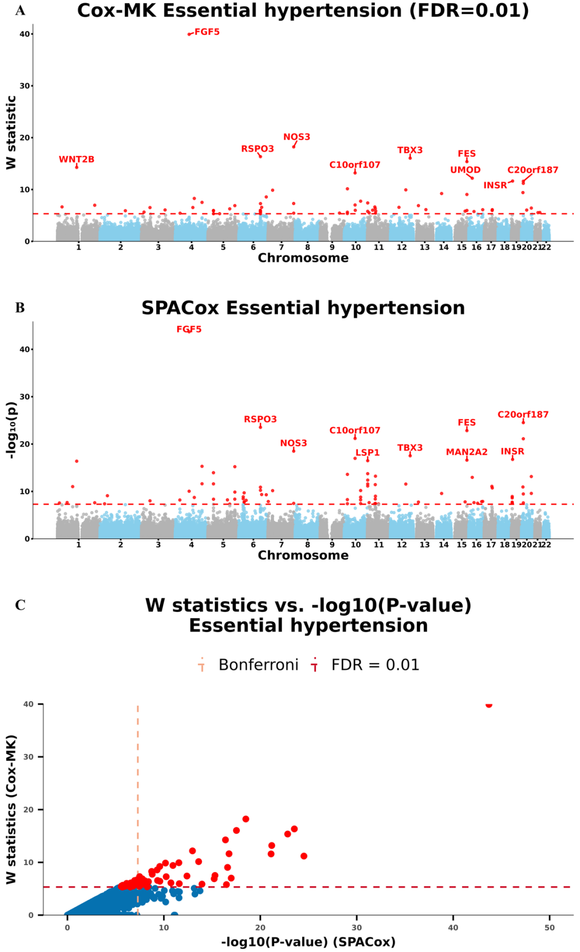
Figure S8. Manhattan plots for GWAS of essential hypertension in the UK Biobank data with White British ancestry. (A and B) GWAS results using (A) Cox-MK and (B) SPACox are shown for essential hypertension. (C) Scatter plot of W knockoff statistics (Cox-MK) vs. −log10(P-value) (SPACox) for essential hypertension.
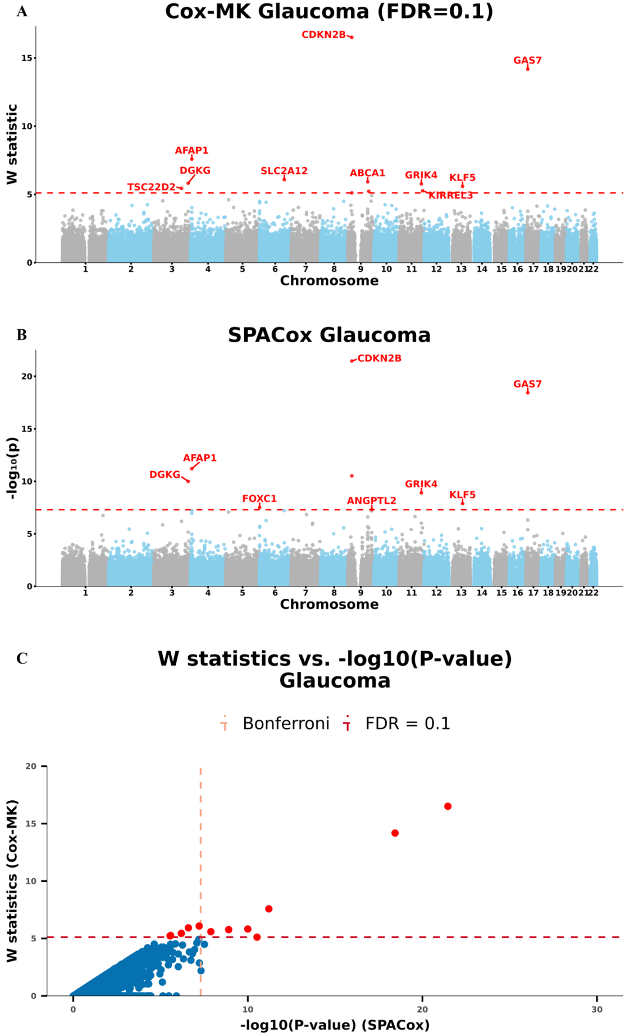
Figure S9. Manhattan plots for GWAS of glaucoma in the UK Biobank data with White British ancestry. (A and B) GWAS results using (A) Cox-MK and (B) SPACox are shown for glaucoma. (C) Scatter plot of W knockoff statistics (Cox-MK) vs. −log10(P-value) (SPACox) for glaucoma.
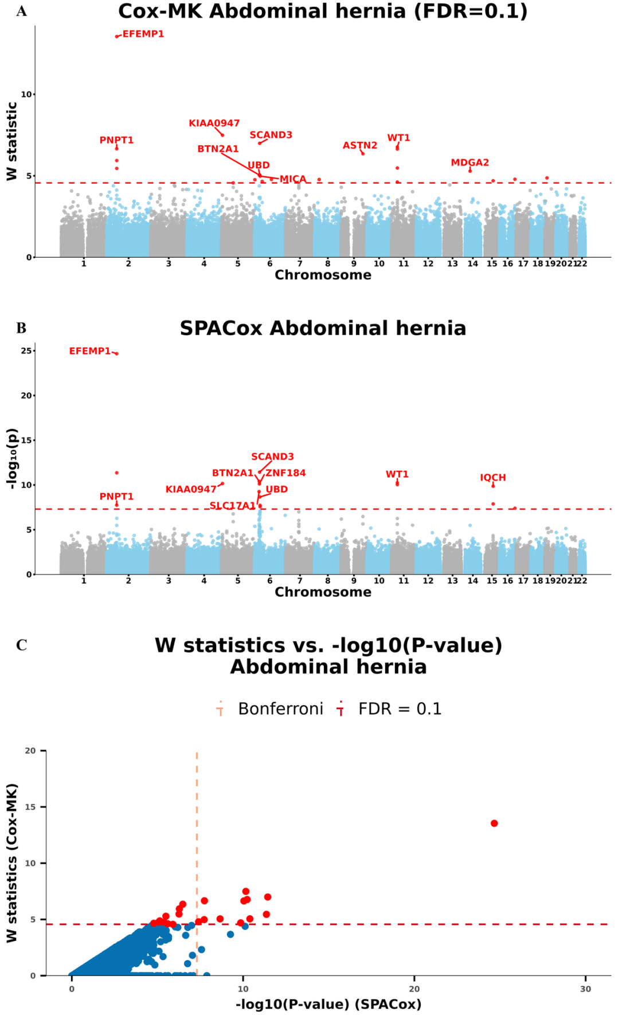
Figure S10. Manhattan plots for GWAS of abdominal hernia in the UK Biobank data with White British ancestry. (A and B) GWAS results using (A) Cox-MK and (B) SPACox are shown for abdominal hernia. (C) Scatter plot of W knockoff statistics (Cox-MK) vs. −log10(P-value) (SPACox) for abdominal hernia.
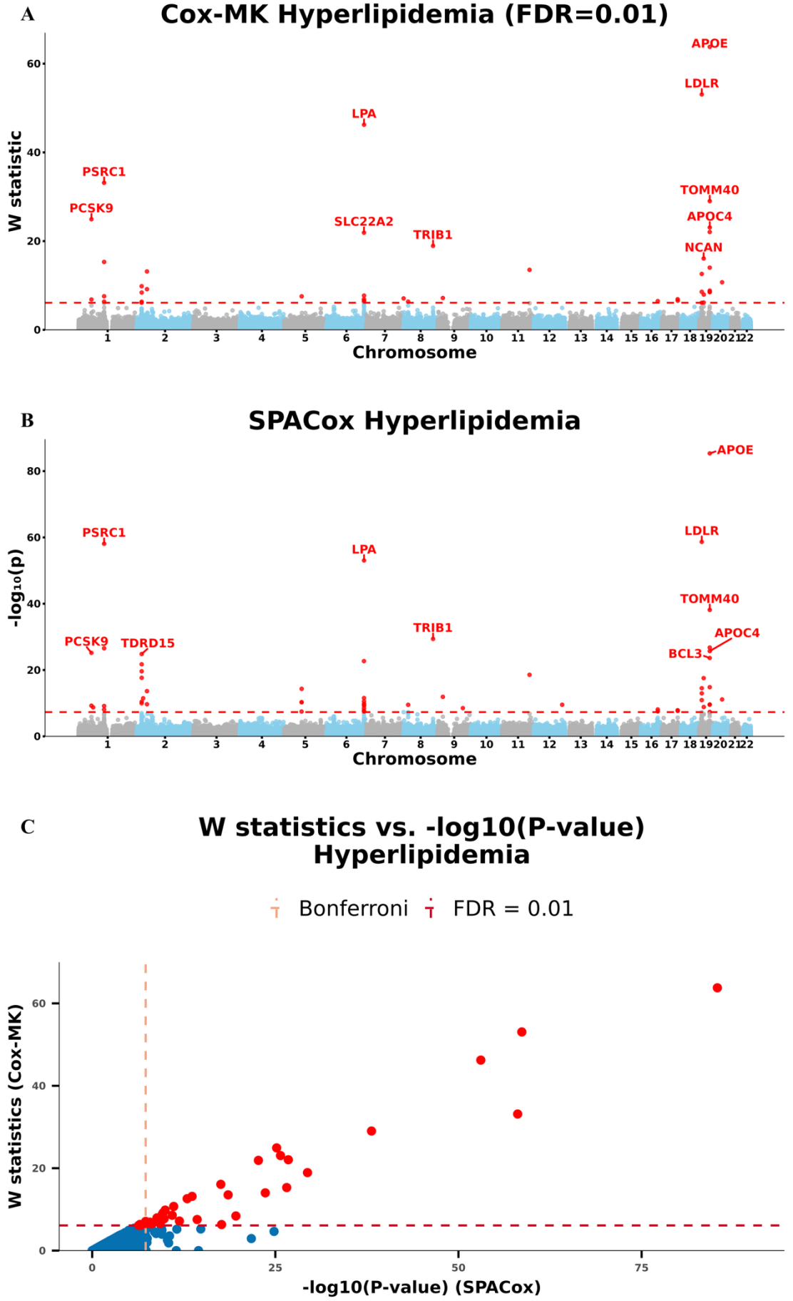
Figure S11. Manhattan plots for GWAS of hyperlipidemia in the UK Biobank data with White British ancestry. (A and B) GWAS results using (A) Cox-MK and (B) SPACox are shown for hyperlipidemia. (C) Scatter plot of W knockoff statistics (Cox-MK) vs. −log10(P-value) (SPACox) for hyperlipidemia.
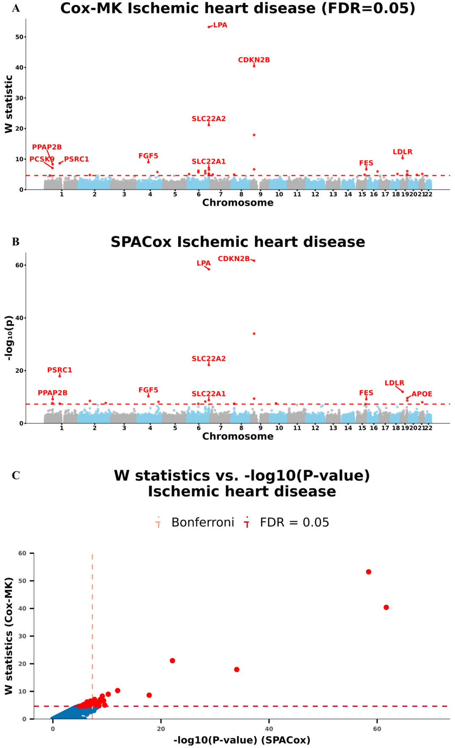
Figure S12. Manhattan plots for GWAS of ischemic heart disease in the UK Biobank data with White British ancestry. (A and B) GWAS results using (A) Cox-MK and (B) SPACox are shown for ischemic heart disease. (C) Scatter plot of W knockoff statistics (Cox-MK) vs. −log10(P-value) (SPACox) for ischemic heart disease.
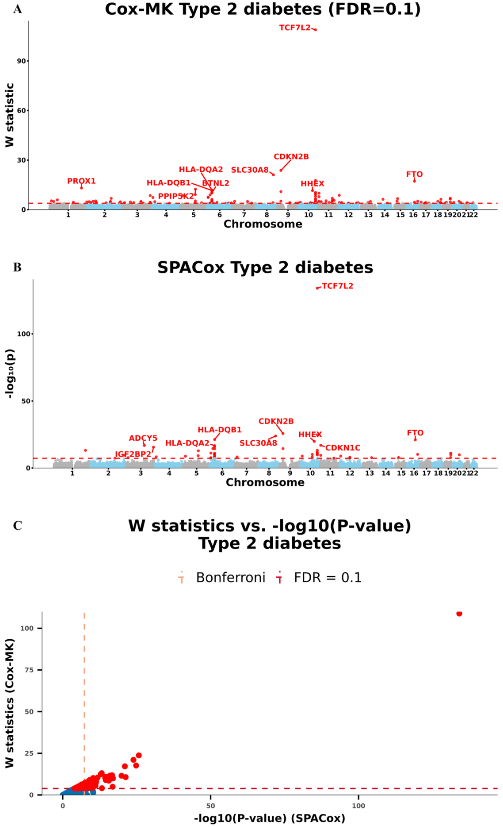
Figure S13. Manhattan plots for GWAS of type 2 diabetes in the UK Biobank data with White British ancestry. (A and B) GWAS results using (A) Cox-MK and (B) SPACox are shown for type 2 diabetes. (C) Scatter plot of W knockoff statistics (Cox-MK) vs. −log10(P-value) (SPACox) for type 2 diabetes.

